1 HARYANA R&V SQN NCC, HISAR
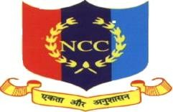

Established : |  | 16 Nov 2001 | Authorized strength : | 200+52*  * additional vacancies
Contact (off) : |  | 01662-283222 | E-mail (off) : | 1harncchisar@gmail.com
(FAX) | : | 01662-283222

OFFICER COMMANDING
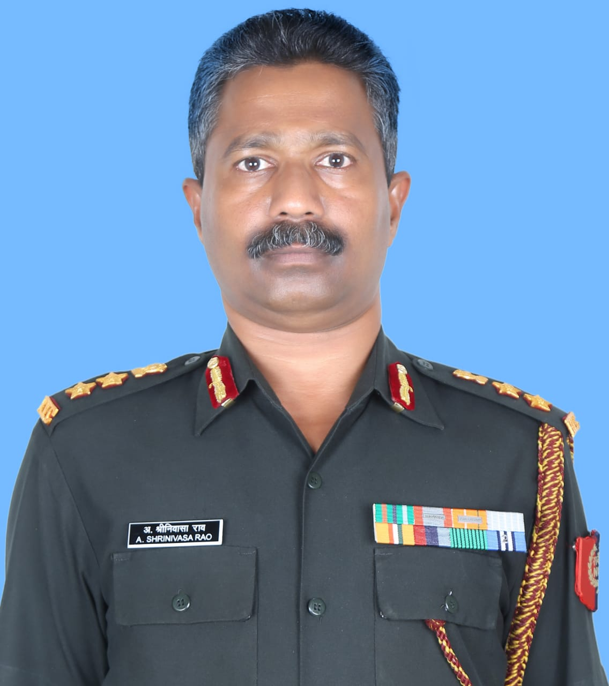
Col AS Rao
Mob : 6006711658
Email : srinivasa_unmis@rediffmail.com

ANOs/ CTOs
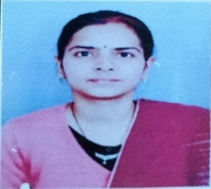

Dr. Archana Lohiya, CTO wef 01 Sep 2022 Asstt Prof
archana.lohiya@luvas.edu.in

Dr. Narender Singh, CTO wef 01 Sep 2022 Asstt Prof
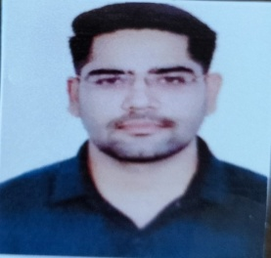
singhnarender32vet@gmail.com

MOTTO : UNITY & DISCIPLINE

Objectives : * To develop character, comradeship, discipline, leadership, secular outlook, spirit of adventure, sportsmanship and ideals of selfless service in the youth of the country.
- To create a human resource of organized, trained and motivated youth to provide leadership in all walks of life and always be available for the service to the nation.
- To provide a suitable environment to motivate the youth to take up a career in the Armed Forces.

Details of Officers Commanding of unit since its establishment

Ser No. | Rank | Name | Period
 |  |  | From | To
1. | Col | NS Nara | 13-05-2002 | 16-04-2005
2. | Lt Col | Ashwini Goel | 17-04-2005 | 06-05-2008
3. | Lt Col | BS Malik | 28-05-2008 | 26-06-2010
4. | Lt Col | PP Gorah | 27-06-2010 | 03-07-2012
5. | Col | SC Gatt | 04-07-2012 | 31-07-2014
6. | Lt Col | Shitiz Mittal | 01-08-2014 | 10-07-2016
7. | Col | DV Nehra | 11-07-2016 | 06-03-2019
8. | Col | DS Duhan | 07-03-2019 | 26-10-2021
9. | Lt Col | SK Dahiya | 27-10-2021 | 18-11-2022
10 | Col | AS Rao | 19-11-2022 | Till date

SUMMARY OF INCENTIVES/ FINANCIAL BENEFITS GIVEN BY LALA LAJPAT RAI UNIVERSITY OF VETERINARY AND ANIMAL SCIENCES (LUVAS), HISAR TO CADETS OF 1 HARYANA R&V SQN NCC, HISAR ON WINNING MEDALS IN EQUESTRIAN EVENTS OF RDC AS WELL AS ON PARTICIPATION

Ser No. | Type of incentive | Gold Medal Winner (Amount in Rs.) |  | Silver Medal Winner (Amount in Rs.) |  | Bronze Medal  Winner (Amount in Rs.) |  | Participant (Amount in Rs.)
 |  | Hostler | Day Scholar | Hostler | Day Scholar | Hostler | Day Scholar | Hostler | Day Scholar
1. | Sports Kit | 2200 | 2200 | 2200 | 2200 | 2200 | 2200 | 2200 | 2200
2. | Track Suit | 900 | 900 | 900 | 900 | 900 | 900 | 900 | 900
3. | Cash Incentive | 10000 | 10000 | 8000 | 8000 | 6000 | 6000 | - | -
4. | Free meals facility | 38325@ | 24000* | 38325 | 24000 | - | - | - | -
5. | Free Milk @1 ltr per day | 16060# | 14600** | 16060 | 14600 | - | - | - | -
Total (in Rs.) |  | 67485 | 51700 | 65485 | 49700 | 9100 | 9100 | 3100 | 3100

@ At rate of Rs 105 per day as per prevalent diet charges in University i.e. Rs 105 x 365 days.
* @ Rs 2000/- per month fixed for Day Scholars i.e. Rs 2000 x 12 Months.
# @ Rs 44/- per Kg as per prevalent milk rates in University i.e. Rs 44 x 365 days.
** @ Rs 40/- fixed by University for Day scholars i.e. Rs. 40 x 365 Days.

Note :- CASH PRIZE OF Rs. 10000/- & Rs. 8000/- FOR BEING BEST RIDER & BEST RIDER (RUNNER UP) RESPECTIVELY WILL BE GIVEN IN ADDITION TO ABOVE INCENTIVES ADMISSIBLE FOR INDIVIDUAL MEDAL/ACHIEVEMENT

- Achievements in Equestrian events at RDC

Ser No. | Year | No. of Cadets | Medals Won |  |  |  | Trophies Won |  |  | Name of Cadet
 |  |  | Gold | Silver | Bronze | Total | Winner | Runner-up | Total
1. | 2008 | 05 | 01 | 01 | - | 02 | - | - | - | Pradeep Kumar-01 Gold
 |  |  |  |  |  |  |  |  |  | Nagaleelavthi S.P.-01 Silver
2. | 2009 | 05 | 02 | 01 | 03 | 06 | - | - | - | Ritika Dahiya-02 Gold
 |  |  |  |  |  |  |  |  |  | Archana Lohiya-01 Silver
 |  |  |  |  |  |  |  |  |  | Pawan Kumar-02 Bronze
 |  |  |  |  |  |  |  |  |  | Joginder Singh-01 Bronze
3. | 2010 | 05 | 03 | 01 | - | 04 | 01 | - | 01 | Sunil Malik-02 Gold & 01 Trophy
 |  |  |  |  |  |  |  |  |  | Jagdeep Dalal-01 Gold
 |  |  |  |  |  |  |  |  |  | Monika Sharma-01 Silver
4. | 2011 | 05 | 04 | 02 | 02 | 08 | 03 | 01 | 04 | Mohit Yadav-02 Gold, 01 Silver & 02 Trophy
 |  |  |  |  |  |  |  |  |  | Vijay Vikash-01 Gold
 |  |  |  |  |  |  |  |  |  | Suman-01 Gold
 |  |  |  |  |  |  |  |  |  | Sonu Kumari-01 Silver, 02 Bronze & 01 Trophy
 |  |  |  |  |  |  |  |  |  | Chirag Bharadwaj-01 Runners- up Trophy
5. | 2012 | 05 | 04 | 04 | - | 08 | 01 | 01 | 02 | Arun Sejwal-02 Gold, 01 Silver, 01 Trophy & 01 Runners-up Trophy
 |  |  |  |  |  |  |  |  |  | Ajit Verma-01 Gold
 |  |  |  |  |  |  |  |  |  | Parveen Yogi-01 Gold
 |  |  |  |  |  |  |  |  |  | Sushma Kumari-02 Silver
 |  |  |  |  |  |  |  |  |  | Jyoti Beniwal-01 Silver
6. | 2013 | 05 | 02 | 05 | - | 07 | 02 | - | 02 | Arun Sejwal-02 Gold, 02 Silver & 02 Trophies
 |  |  |  |  |  |  |  |  |  | Dinesh Gulia-02 Silver
 |  |  |  |  |  |  |  |  |  | Sonu Dahiya-01 Silver
7. | 2014 |  | - Not Participated -
8. | 2015 | 04 | 01 | 01 | 01 | 03 | 01 | - | 01 | Reetu Rani-01 Gold & 01 Silver
 |  |  |  |  |  |  |  |  |  | Vikas-01 Bronze & 01 Trophy
9. | 2016 | 04 | 01 | 01 | 02 | 04 | 01 | 01 | 02 | Reetu Rani-01 Gold, 01 Silver 01 Bronze & 01 Trophy
 |  |  |  |  |  |  |  |  |  | Ankit-01 Bronze & 01 Runners- up Trophy
10. | 2017 | 04 | 02 | 01 | 01 | 04 | - | 02 | 02 | Ankit Dangi-01 Gold, 01 Silver,  01 Bronze & 02 Runners-up Trophies
 |  |  |  |  |  |  |  |  |  | Amit Kumar-01 Gold
11. | 2018 | 04 | 02 | 02 | 03 | 07 | 01 | 02 | 03 | Diksha-01 Gold, 01 Silver, 01 Bronze & 01 Runners-up Trophy
 |  |  |  |  |  |  |  |  |  | Dheeraj Yadav-01 Gold & 01 Trophy
 |  |  |  |  |  |  |  |  |  | Khushbu- 01 Silver
 |  |  |  |  |  |  |  |  |  | Sourabh-02 Bronze & 01 Runners-up Trophy
12. | 2019 | 04 | 04 | - | 05 | 09 | - | 01 | 01 | Sahil Dulat – 02 Gold
Naveen Kumar – 01 Gold, 02 Bronze & Best Rider Runners-
up Trophy
 |  |  |  |  |  |  |  |  |  | Mamta Chahal – 01 Gold & 02 Bronze
 |  |  |  |  |  |  |  |  |  | Annu Jakhar – 01 Bronze

Ser No. | Year | No. of Cadets |  | Medals Won |  |  |  | Trophies Won |  |  | Name of Cadet
 |  |  |  | Gold | Silver | Bronze | Total | Winner | Runner-up | Total
13. | - Not Participated Due to Covid-19-
14. | - Not Participated Due to Covid-19-
15. | 2023 | 03 | 01 |  | - | 01 | 02 | - | - | - | Vaibhav Rana of MNSS Rai

(B) Achievement in Various Horse Shows
Ser No. | Name of Tournaments | Year | Medals Won |  |  |  | Name
 |  |  | Gold | Silver | Bronze | Total
1. | Delhi Horse Show | 2011 | - | - | 03 | 03 | Sunil Malik-03 Bronze
2. | Delhi Horse Show | 2015 | - | 04 | 06 | 10 | Vishal-02 Silver & 01 Bronze
 |  |  |  |  |  |  | Ankit-02 Silver
 |  |  |  |  |  |  | Vikas Godara-02 Bronze
 |  |  |  |  |  |  | Vikas-02 Bronze
 |  |  |  |  |  |  | Jai Singh-01 Bronze
3. | PAP Chandigarh Horse Show | 2015 | 01 | 01 | - | 02 | Naveen Kumar-01 Gold & 01 Silver
4. | ITBP Panchkula Horse Show | 2015 | 04 | - | 01 | 05 | Naveen Kumar-03 Gold
 |  |  |  |  |  |  | Reetu Rani-01 Gold
 |  |  |  |  |  |  | Ankit Dangi-01 Bronze
5. | Haryana Swaran Jayanti Horse Show at Gurgaon | 2017 | 13 | 08 | 07 | 28 | Diksha-03 Gold
 |  |  |  |  |  |  | Sourabh-02 Gold
 |  |  |  |  |  |  | Sahil-02 Gold
 |  |  |  |  |  |  | Parshant-01 Gold, 02 Silver & 01 Bronze
 |  |  |  |  |  |  | Jai Singh- 01 Gold, 01 Silver & 01 Bronze
 |  |  |  |  |  |  | Ajeet Verma-01 Gold & 01 Bronze
 |  |  |  |  |  |  | Dheeraj Yadav-02 Silver
 |  |  |  |  |  |  | Divya-02 Silver
 |  |  |  |  |  |  | Priyanka-02 Bronze
 |  |  |  |  |  |  | Khushbu-01 Bronze
 |  |  |  |  |  |  | Anju Poonia-01 Bronze
 |  |  |  |  |  |  | Team Events-03 Gold & 01 Bronze
6. | National Tent Pegging Championship | 2018 | - | - | - | - | Akashdeep Indora – Participation Team Event
 |  |  |  |  |  |  | Pardeep Singh - Participation Team Event
 |  |  |  |  |  |  | Amandeep - Participation Team Event
 |  |  |  |  |  |  | Naveen Kumar - Participation Team Event
 |  |  |  |  |  |  | Pankaj Soni – Participation Individual ‘Lance’
7. | Haryana Horse Show | 2018 | 10 | 08 | 06 | 24 | Sahil Dulat – 03 Gold & 01 Bronze
 |  |  |  |  |  |  | Parshant – 02 Gold, 01 Silver & 01 Bronze
 |  |  |  |  |  |  | Annu Jakhar – 01 Gold & 01 Silver
 |  |  |  |  |  |  | Mamta Chahal – 01 Gold & 01 Silver
 |  |  |  |  |  |  | Pardeep Singh – 01 Gold & 01 Bronze
 |  |  |  |  |  |  | Amandeep – 01 Gold
 |  |  |  |  |  |  | Nishkash – 01 Gold
 |  |  |  |  |  |  | Akashdeep Indora – 01 Silver
 |  |  |  |  |  |  | Naveen Kumar – 01 Silver
 |  |  |  |  |  |  | Pankaj Soni – 01 Silver
 |  |  |  |  |  |  | Reenu Devi – 01 Silver
 |  |  |  |  |  |  | Sourabh – 01 Silver
 |  |  |  |  |  |  | Kiran – 01 Bronze
 |  |  |  |  |  |  | Shweta Sabharwal – 01 Bronze

8. | Army Equestrian Championship at Jaipur | 2022 | 02 | 02 | 02 | 06 | Cdt Yogesh-02 Gold
 |  |  |  |  |  |  | Cdt Naveen -01 Silver
 |  |  |  |  |  |  | Cdt Rishab-01 Silver
 |  |  |  |  |  |  | Cdt Aashish-01 Bronze
 |  |  |  |  |  |  | Cdt Sakshi-01 Bronze

Commendation Medal/Appreciation Certificates

  - By Distt Administration Hisar :- Unit was awarded “Appreciation Certificate” for “its remarkable achievements & contribution in the field of NCC Activities” by Distt administration Hisar on the occasion of Independence Day-2016.

  - By ADG, NCC DTE PHHP&C, Chandigarh :- Following persons of this unit were awarded
“ADG Appreciation Certificate” during July 2018 for their outstanding and exemplary work/achievement.
    - Dr. Anika Malik, CTO
    - SQMD Pawan Kumar
    - Syce Rohit Sharma
    - SUO Dheeraj Yadav
    - SUO Diksha

  - By Ministry of Defence Govt. of India :- Col DV Nehra, Commanding Officer was awarded
“Chief of Army Staff Commendation Medal” on the occasion of Independence Day -2018

Horse Riding Expedition : 18 Mar – 23 Mar 2017
- 1 Haryana R&V Sqn NCC, Hisar under the aegis of NCC Group Headquarter Rohtak pioneered the conduct of Horse Riding Expedition from 18 – 23 Mar 2017 consisting of 05 Girls and 05 Boys cadets on horse back. The expedition was flagged off by Dr Gurdial Singh, Dean College of Veterinary Sciences, Hisar (Now Vice Chancellor, LUVAS, Hisar) on 18 Mar 2018. The cadets covered about 30 villages & a distance of approx 150 Kms in 06 days on Horse Back, main focus being spreading awareness about NCC in the Interior/Rural Haryana as also spreading awareness on ‘Beti Bachao – Beti Padhao’, ‘Swachh Bharat Abhiyaan and other critical ongoing campaigns.
- During the course of the rallies, cadets visited village chaupals/Schools/Institutions enroute and delivered short and crisp lectures to convey the social messages to the rural population. In addition, horse show was conducted in the evening at halting villages, a total of 06 such Horse shows were conducted during the rally. It was heartening to see the enthusiasm, overwhelming support, hospitality and warmth extended by local populace towards the NCC cadets during the entire duration of the expedition.
- The selected cadets got an opportunity in the first ever Horse Riding expedition in North India, an event thoroughly enjoyed by one and all. Besides a competitive 22-28 Kms per day, the cadets got an opportunity to interact with local populace of Interior Haryana and learnt about their rich culture and heritage. The cadets participated with extreme enthusiasm and were always motivated. The rise in their confidence level was amply visible as more and more volunteered to participate in hosting ceremonies and in show jumping/tent pegging events of ‘Horse Show’ at successive stops.

- The Expedition concluded at Hisar on 23 Mar 2017, with a debriefing by Col DV Nehra, OIC of the expedition. Brig BS Dalal, Gp Cdr, NCC Gp HQ, Rohtak interacted with the cadets & took feedback from them. He presented mementoes to the participants of the expedition and lauded the unit for undertaking such a difficult task of Horse Riding for the first time in North India. After the campfire, the cadets broke off highly satisfied & motivated on the culmination of an extremely successful event.

Participants of Horse Riding Expedition:-
  - Cadets/Riders

SER  NO | REGT NO | RANK | NAME | UNIT
1. | HAR/SW/2014/10003 | SUO | Anju Poonia | College of Veterinary Sciences, LUVAS, Hisar
2. | HAR/SW/2015/10005 | CPL | Diksha Danwar | -do-
3. | HAR/SW/2015/10007 | SGT | Khushbu | -do-
4. | HAR/SW/2015/10014 | CPL | Priyanka Pheoran | -do-
5. | HAR/SW/2015/10027 | CPL | Divya | College of Agriculture CCS HAU, Hisar
6. | HAR/SD/2014/10005 | SGT | Amit Kumar | College of Veterinary Sciences, LUVAS, Hisar
7. | HAR/SD/2014/10046 | SGT | Shivansh Mehra | -do-
8. | HAR/SD/2015/10001 | CPL | Abhey Singh | -do-
9. | HAR/SD/2015/10013 | CPL | Dheeraj Yadav | -do-
10. | HAR/SD/2015/10016 | CPL | Jai Singh | -do-

Support Staff

Ser  No | Regt no | Rank | Name | Unit
1. | V-0498L | Col | AS Rao | 1 Har R&V Sqn NCC, Hisar
2. | JC-797881X | Ris(Rdr) | SK Sharma | 1 Har R&V Sqn NCC, Hisar
3. | 7243154L | SQMD | Dileesh P | 1 Har R&V Sqn NCC, Hisar
4. | 7243637H | Rdr NCO | Anurag Singh | 1 Har R&V Sqn NCC, Hisar
5. | 7243119H | DFR/Farr | Sanjiv Jagdish | 1 Har R&V Sqn NCC, Hisar
6. | 7242548X | DFR/NAVET | Ashok Kumar | 1 Har R&V Sqn NCC, Hisar

Routine Activities being conducted by NCC Unit

Ser No | Activity | Location | Duration
1. | Horse Riding | LUVAS | Every day Morning & Evening
2. | Drill | LUVAS | 04:30 – 06:30 PM every Monday- Wednesday
3. | Annual Training Camp | To be decided as per availability | Once every year for 2nd & 3rd year cadets only
4. | Blood Donation Camp | ATC Camp site | During Annual Training Camp
5. | Republic Day Camp RDC | New Delhi | December & January
6. | Army Attachment Camp | RVC Centre & College Meerut Cantt. | As per schedule given by DG NCC
7. | National Integration Camp | To be decided by DGNCC | -do-
8. | Republic Day Parade | Giri Centre, CCS HAU, Hisar | 26 January
9. | ‘BEE’ Certificate Examination | LUVAS, Hisar | Every year in Feb/Mar

Routine Activities being conducted by NCC Unit

10. | ‘CEE’ Certificate Examination | NCC Gp HQ, Rohtak | Every year in Feb  (3rd Sunday of Feb)
11. | World Veterinary Day | LUVAS, Hisar | Last Saturday of April
12. | Yoga Day | LUVAS, Hisar | 21 June
13. | Swacchta Abhiyan | LUVAS, Hisar & adopted village Niyana (Hisar) | Routinely
14. | Teaching of e-payment methodology | Adopted village Niyana (Hisar) | Every 06 monthly
15. | Tree Plantation | LUVAS, Hisar & adopted village Niyana (Hisar) | Every year in July
16. | Motivational lectures by OC/experts | LUVAS, Hisar | Regularly

