Department of Veterinary Public Health and Epidemiology
Departmental Activities
Year 2023-24
World Zoonoses Day Celebrated with Enthusiasm at LUVAS: A Call for Vigilance and One Health Awareness
The Department of Veterinary Public Health and Epidemiology at LUVAS marked World Zoonoses Day with an engaging and informative event designed to raise awareness about zoonotic diseases and promote the One Health approach among budding veterinarians.
The event featured a quiz competition that saw enthusiastic participation from both undergraduate and postgraduate students. Participants demonstrated their knowledge on zoonoses, epidemiology, and public health, creating a vibrant atmosphere of learning and competition.
Highlighting the event were two impactful lectures by esteemed experts in the field. Dr. Renu Gupta, Senior Disease Investigation Officer, captivated the audience with her detailed talk on the “Handling and Management of Zoonotic Disease Outbreaks.” She emphasized the importance of timely disease detection, coordinated response mechanisms, and intersectoral collaboration during outbreaks.
Adding to the depth of the session, Dr. Manesh Kumar, Assistant Professor, VPHE, delivered a thought-provoking presentation on “Zoonoses and the One Health Approach,” providing attendees with updated insights into the interconnectedness of animal, human, and environmental health.
The event concluded with an open-house quiz and discussion, allowing students and faculty to interact freely, pose questions, and share ideas. This was followed by a high tea session, promoting informal dialogue and camaraderie.
Winners of the quiz and active participants were honoured with certificates of appreciation, recognizing their enthusiasm and commitment to public health learning.
This event not only commemorated the legacy of Louis Pasteur’s rabies vaccine but also reinforced the critical message of vigilance, awareness, and interdisciplinary cooperation in combating zoonotic threats.
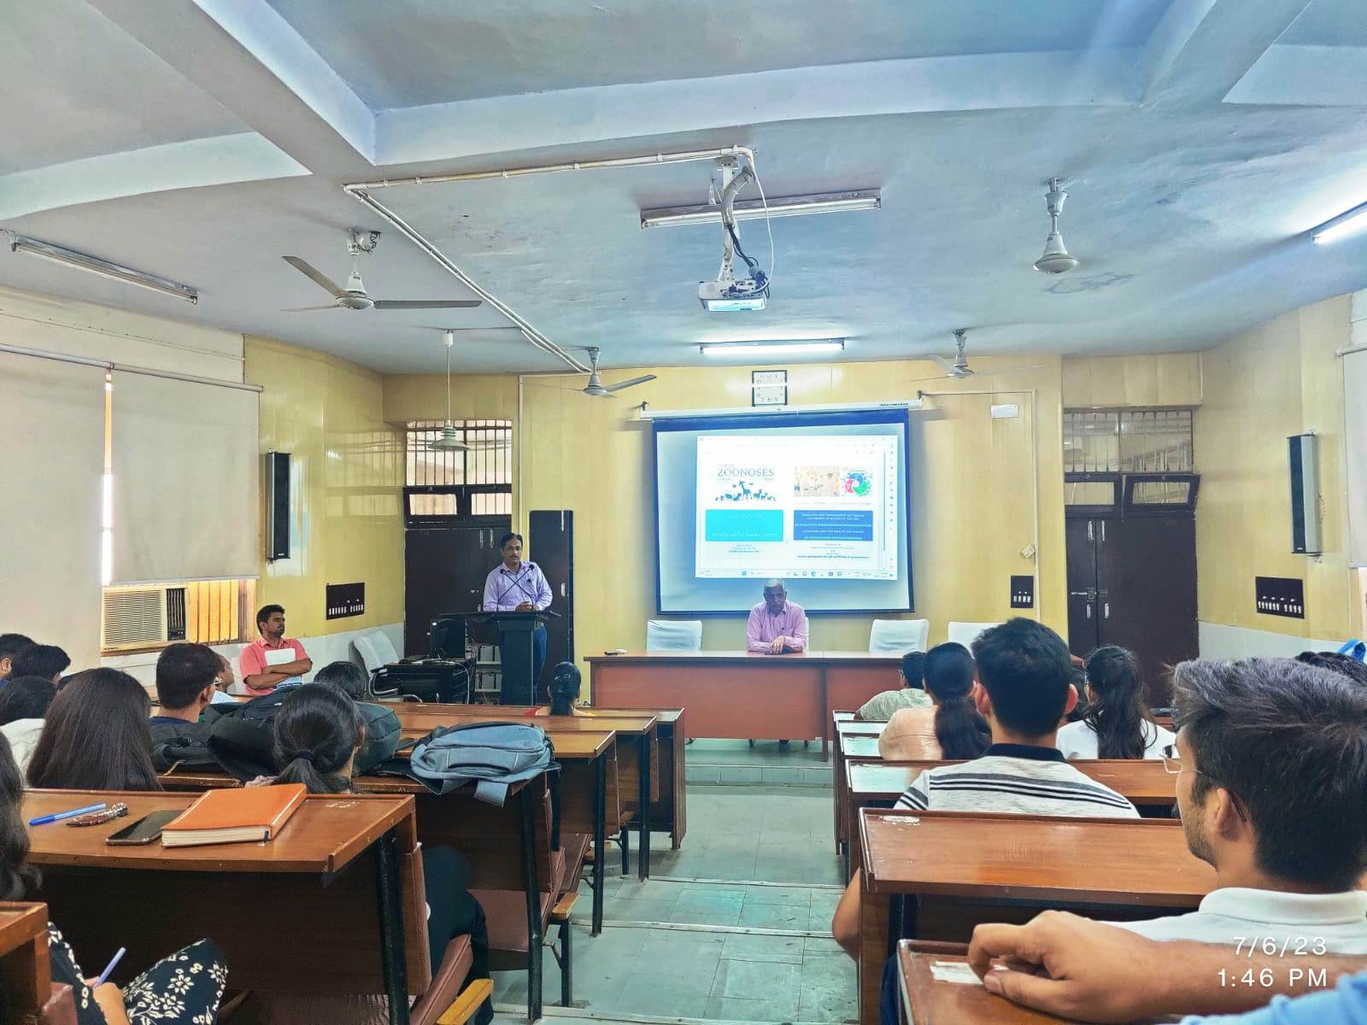

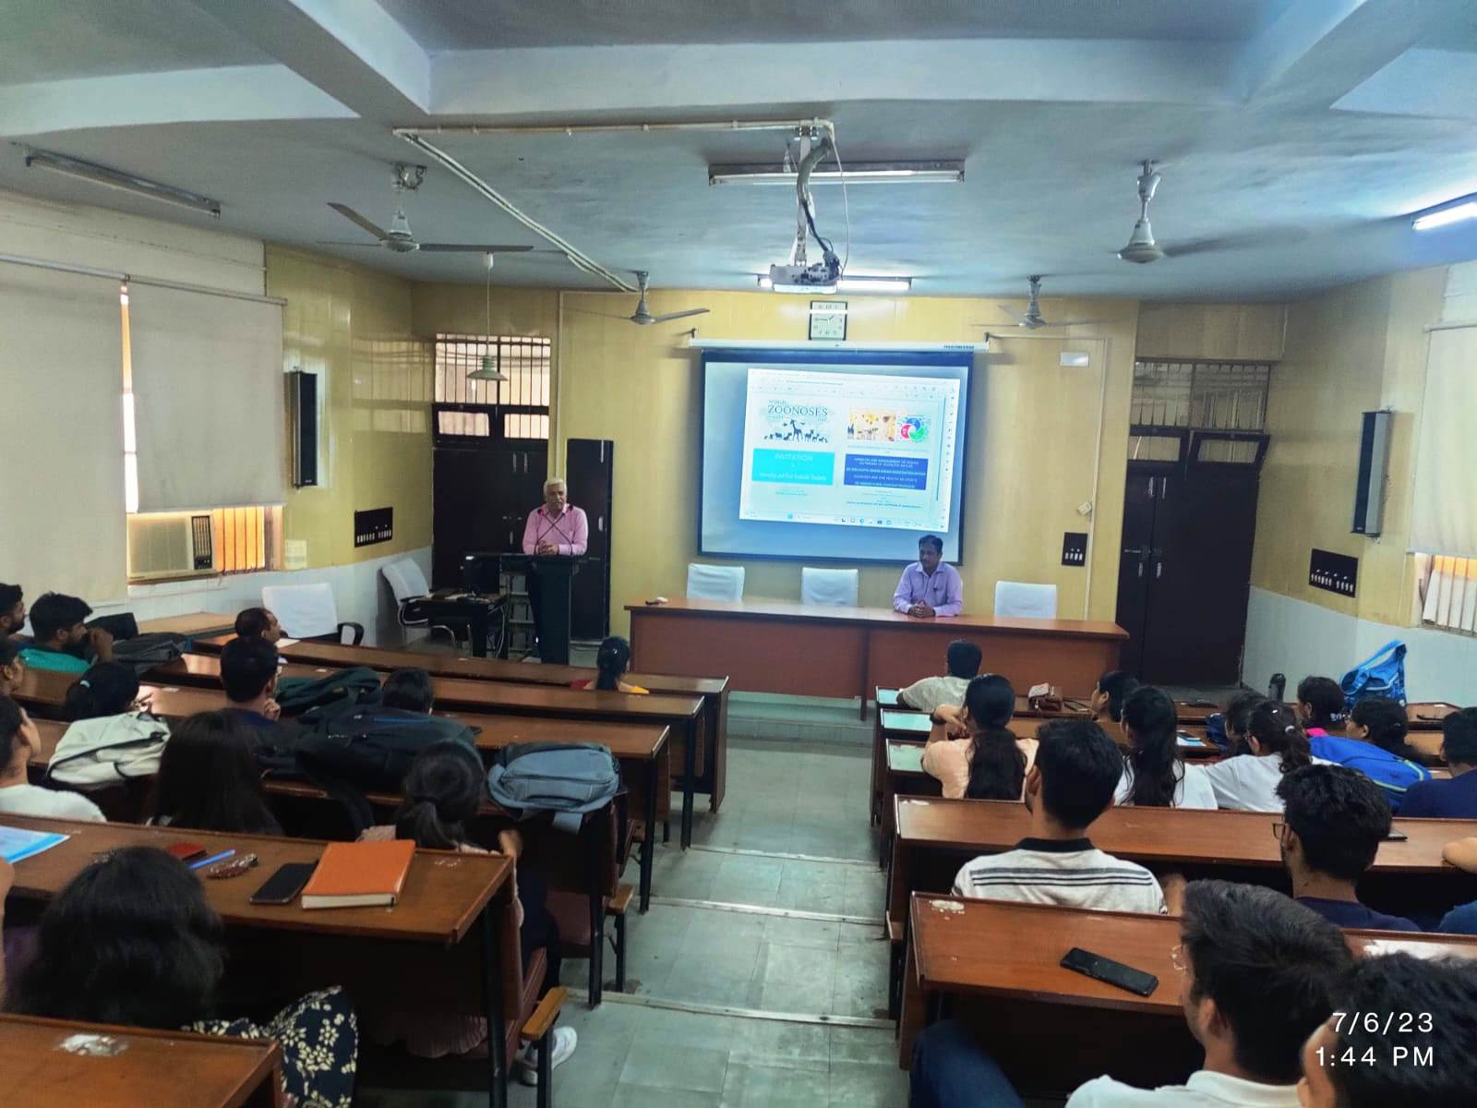

LUVAS Hosts National Workshop on Chromatographic Techniques for Food and Environmental Analysis
The Department of Veterinary Public Health and Epidemiology at LUVAS successfully conducted a three-day National Workshop titled “Application of Chromatographic Methods for Analysis of Food and Environmental Samples” from 5th to 7th March 2024. The workshop aimed to equip participants with hands-on exposure and theoretical insights into advanced chromatographic techniques pivotal in food safety and environmental monitoring.
A total of 20 participants, including 4 faculty members from LUVAS and 16 postgraduate students from reputed institutions such as LUVAS, Guru Jambheshwar University (GJU), and CCS Haryana Agricultural University (CCSHAU), took part in this intensive learning experience.
Throughout the sessions, participants were introduced to the principles and practical applications of chromatographic methods such as HPLC and GC, commonly used in detecting contaminants and residues in complex matrices. The interactive sessions, live demonstrations, and expert-guided lab work enriched the attendees’ understanding of analytical protocols and quality assurance.
Participants expressed high levels of satisfaction and appreciation for the workshop’s structure, content, and resource persons. Many highlighted how the training helped them gain new perspectives and technical skills in chromatographic analysis, which are increasingly essential in research and regulatory fields.
The workshop not only enhanced the analytical capabilities of young researchers but also underscored LUVAS’s commitment to academic excellence and its proactive role in advancing public health and food safety standards.
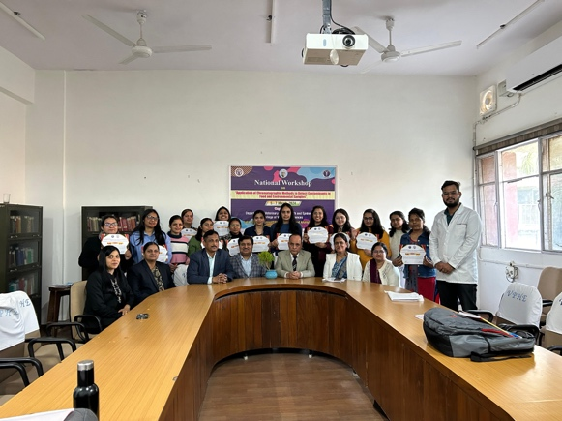

LUVAS Hosts XIXth IAVPHS Annual Conference and National Symposium on One Health
Hisar, December 8, 2023 — The Department of Veterinary Public Health and Epidemiology at LUVAS successfully organized the XIXth Annual Conference of the Indian Association of Veterinary Public Health Specialists (IAVPHS) along with a National Symposium on the theme “Promotion of One Health: Opportunities, Challenges and Solutions” on 7th and 8th December 2023 at the university campus in Hisar, Haryana.
The prestigious two-day event attracted over 150 participants, including distinguished faculty members, researchers, and students from universities and institutions across India, making it a significant gathering of minds working at the intersection of animal, human, and environmental health.
The conference featured six dynamic technical sessions, each focused on critical sub-themes under the broader umbrella of One Health. Participants showcased their research through oral and poster presentations, addressing pressing public health issues such as antimicrobial resistance, food safety, zoonotic disease surveillance, and integrated disease management.
A major highlight of the event was the award distribution ceremony, where exceptional contributions were recognized. Awards for Best Oral and Poster Presentations, along with several other honors constituted by the IAVPHS, were conferred upon deserving participants in recognition of their academic excellence and innovative research.
The conference not only facilitated intellectual exchange and collaboration among stakeholders but also reinforced the importance of interdisciplinary strategies for tackling global health challenges. The successful conduct of this event reaffirmed LUVAS's leading role in advancing veterinary public health education and research in India.
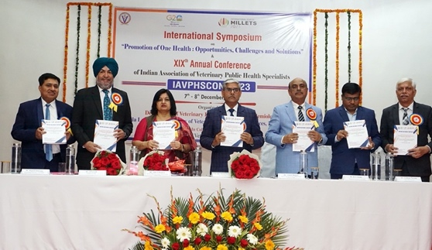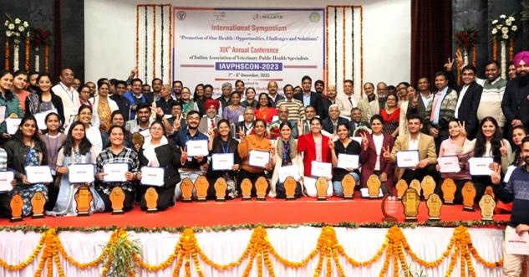

LUVAS Hosts NARES-BLP Workshop in Collaboration with IARI Faculty
In a significant stride toward educational innovation in agriculture, LUVAS successfully organized a two-day workshop on the National Agricultural Resilient Education System – Blended Learning Programme (NARES-BLP) on 3rd and 4th November 2023, in collaboration with faculty from the Indian Agricultural Research Institute (IARI).
The workshop aimed to promote modern pedagogical tools and blended learning methodologies in veterinary and agricultural education under the NARES framework, initiated by the Indian Council of Agricultural Research (ICAR). It brought together educators, curriculum developers, and digital learning experts for knowledge exchange and collaborative planning.
During the event, faculty from IARI shared their experiences, strategies, and case studies on integrating e-learning platforms, multimedia tools, and outcome-based teaching into academic curricula. Participants gained hands-on exposure to digital content development, learning management systems, and student engagement through technology-enhanced learning.
The workshop underscored the urgent need for resilient and adaptive educational models to address evolving challenges in agriculture, animal health, and public health education. It also strengthened institutional ties between LUVAS and IARI, promoting academic synergy and capacity-building.
The event was well-received by faculty and academic leaders, who appreciated the opportunity to align with national standards in blended learning and digital pedagogy.

Year 2024-25
World Rabies Day Celebrated with Enthusiasm at LUVAS: A Call for Vigilance and One Health Awareness
The Department of Veterinary Public Health and Epidemiology and Disease Investigation Laboratories at LUVAS marked World Rabies Day with an engaging and informative event designed to raise awareness and to educate about Rabies to the school children and other public at various schools and places of the Haryana state.
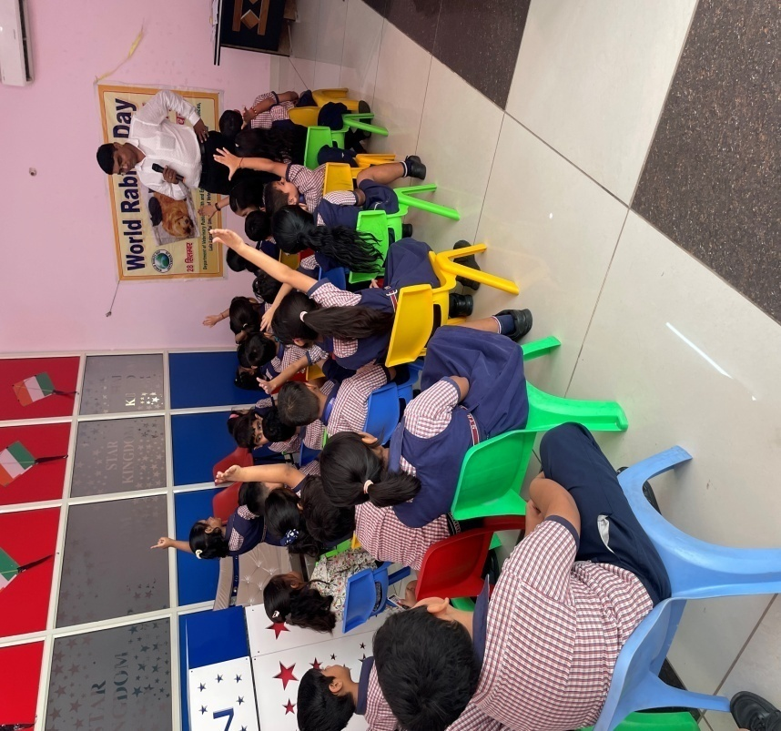
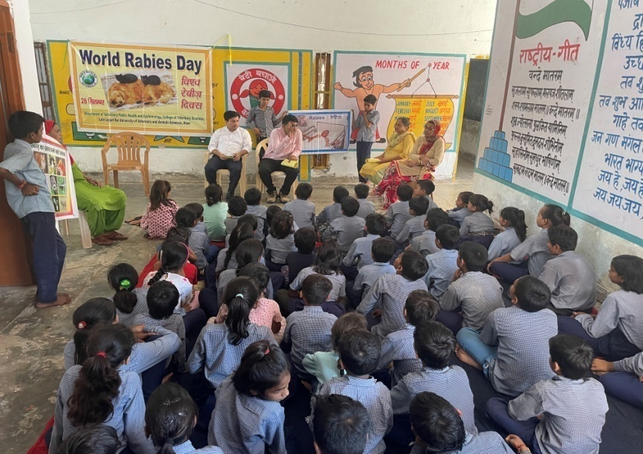

LUVAS Observes Antibiotic Awareness Week with FAO-India Collaborative Workshop
As part of the global observance of World Antibiotic Awareness Week, the Department of Veterinary Public Health and Epidemiology at Lala Lajpat Rai University of Veterinary and Animal Sciences (LUVAS), Hisar, organized a one-day workshop on 21st November 2024, in collaboration with the Food and Agriculture Organization (FAO) of the United Nations – India.
The workshop aimed to raise awareness about the responsible use of antimicrobials and to combat the growing threat of antimicrobial resistance (AMR)—a pressing global public health concern. Bringing together students, researchers, and faculty members, the event served as a platform to discuss strategies for antibiotic stewardship in veterinary and animal health practices.
Expert speakers from LUVAS and FAO-India delivered insightful presentations covering key topics such as judicious antimicrobial use in livestock, AMR surveillance, and the One Health approach to mitigate the spread of resistant pathogens across sectors.
Participants engaged in interactive discussions on the role of veterinarians, farmers, and policymakers in safeguarding antibiotics for future generations. The workshop concluded with a collective call for adopting science-based, sustainable solutions to reduce AMR risks in veterinary and food systems.
The event reflected LUVAS's ongoing commitment to public health and its proactive collaboration with international agencies in addressing global health challenges through education, awareness, and research.

