**The registration fee may be remitted only to A/C……………./Demand draft drawn in favour of “Organising Secretary, 24th IVC, LUVAS, Hisar” maintained with PNB (IFSC Code: PUNB0976100), HAU Campus, Hisar, Haryana.**

|  |  |  |
| --- | --- | --- |
| **Registration Category** | **Registration on or before 05.01.2024**  **(in ₹)** | **Late/on spot registration**  **(in ₹)** |
| **IAAVR Member** | **4500/-** | **5500/-** |
| **Non-IAAVR Member** | **5000/-** | **6000/-** |
| **Accompanying person** | **2500/-** | |
| **Student/ Research Scholar/post doc/Retd. Professional** | **2000/-** | **3000/-** |
| **Industry/ Corporate** | **9000/-** | **10000/-** |

**The registration fee may be remitted only to A/C……………./Demand draft drawn in favour of “Organising Secretary, 24th IVC, LUVAS, Hisar” maintained with PNB (IFSC Code: PUNB0976100), HAU Campus, Hisar, Haryana.**

**REGISTRATION FORM**

**ORGANISING COMMITTEE**

**Patron**

**Dr. Vinod Kumar Verma**

**Vice Chancellor, LUVAS**

**Chairman Organizing Committee**

**Dr. Gulshan Narang**

**Dean, COVS, LUVAS**

**Co-Chairman Organizing Committee**

**Dr. Naresh Jindal**

**Director of Research, LUVAS**

**Organizing Secretary**

**Dr. Anand Kumar Pandey**

**Head, VGO, COVS, LUVAS Hisar**

**Co-Organizing Secretary (Planning & liasoning)**

**Dr. Rajesh Chhabra**

**Head, VMC, COVS, LUVAS, Hisar**

**Co-Organizing Secretary (Execution and Hospitality)**

1. **Dr. Vikas Nehra**

**Head, VPP, COVS, LUVAS, Hisar**

1. **Dr. Ravi Dutt**

**Assistant Professor, VGO, COVS, LUVAS Hisar**

**Treasurer**

**Dr. Sandeep Kumar**

**Assistant Professor,**

**Department of Veterinary Gynaecology & Obstetrics, COVS, LUVAS Hisar**

**ORGANISING COMMITTEES**

**CENTRAL EXECUTIVE**

**COMMITTEE**

**President**

**Dr. S.N. Singh**

**Vice-President**

**Dr. R.K. Bagherwal**

**Founder Secretary**

**Dr. Rishendra Verma**

**Joint Secretary**

**Dr. D.K. Dey**

**Treasurer**

**Dr. T.K. Verma**

**Members**

**Dr. Bablu Kumar**

**Dr. C. S. Sharma**

**Dr. Harshit Verma**

**Dr. Nitin Bhatia**

**Dr. Salauddin Qureshi**

**Dr. Sandeep Singh**

**Dr. Sudeep Solanki**

**Dr. Swaraj Rajkhowa**

**Dr. Ujjwal Kumar De**

**Dr. Vikramadity Upmanyu**

About IAAVR: Indian Association for the Advancement of Veterinary Research [IAAVR] registered under the society Act 21, 1860 represents professionals, researchers and students from all over India engaged in the field of veterinary research institutes universities, pharmaceutical organization and other organizations. Member of the association will uphold the activities and reputation with the association with an aim to serve humanity and animals welfare

ABOUT THE UNIVERSITY AND VETERINARY COLLEGE

Lala Lajpat Rai University of Veterinary and Animal Sciences (LUVAS), Hisar was established by the state government of Haryana in December, 2010 in pursuance of the Haryana Act No. 7 of 2010 notified on 7th April, 2010. The university has its own new campus of 1200 acre area. The College of Veterinary Sciences is one of the oldest Veterinary Colleges in Northern India. From Lyallpur (currently in Pakistan), the Campus at Hisar was shifted consequent to partition of India. The College has 18 departments with well qualified faculty and modern laboratory infrastructure suitable for practical training of veterinary professionals.

**VENUE AND LOCATION:** Hisar is well connected through buses from neighboring states as well as ISBT, Kashmiri Gate, Delhi (24x7). Trains for Hisar could be taken from Delhi: 12555/ Gorakhdham SF Express (Departure New Delhi, 06:05 Hours); 14519/ Kisan Express (Departure Old Delhi, 14:50 Hours); 14085/ Haryana Express (Departure New Delhi, 18:20 Hours).

**EXHIBITION/SPONSORSHIP/ADVERTISEMENT:** It is a golden opportunity to Private players/NGOs/organization to show their products and services. For details, interested my contact Dr. Anand Kumar Pandey, Organising Secretary, 24th IVC at [IAAVR2024@luvas.edu.in](mailto:IAAVR2024@luvas.edu.in) or Mobile: 8278288210.

Front inner side coloured page 50,000

Back outer side coloured page 60,000

Back inner side coloured page 40,000

Front inner first coloured page 30,000

Back inner last coloured page 25,000

Black & white advertisement full page 10,000

Black & white advertisement half page 5000

Banner display at entry and exit of conference hall 30,000

Banner display at inside of conference hall 20,000

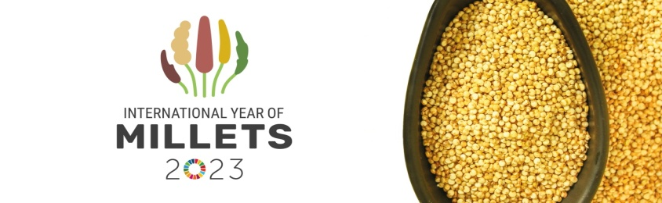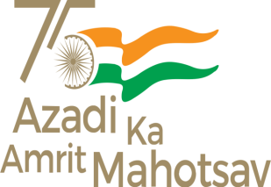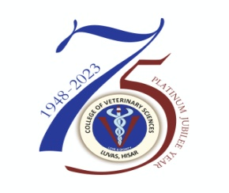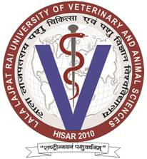

**24th Indian Veterinary Congress & 31th Annual Conference of IAAVR & National Symposium**

**on**

**“Livestock Health and Poultry: A Paradigm Change to Maximize Productivity for Sustainable Farmers’ Livelihood”**

On 7-8 February, 2024

REGISTRATION FORM

1. **Name:** ……………………….
2. **Designation: ……………………….**
3. **Institute/organization:** ……………………….
4. **Address: ……………………….**
5. **Contact No: ………………….WhatsApp No……………….**
6. **Email id: ………………………**
7. **Status of delegate: Life member/Non-life member**
8. **Date & Time of arrival at Hisar ………………Bus/Train number: .......……**
9. **Date & Time of return: ……………………………**
10. **Accommodation required: Yes (……) No(……)**
11. **Accompanying persons: Yes (……) No(……)**

**If yes, give No. (s)Male (……) Female(……) Children (…….)**

1. **Details of registration fee paid/transaction details (copy attach) :……………………………………dated…………………….……**

**(Signature)**

**REGISTRATION AND MODE OF** **PAYMENT**

TECHNICAL SESSIONS

**Call for Abstracts**: Abstracts will be accepted through the online mode or directly to the organising secretary, on or before **January** **05, 2024**.The abstract should not have been presented previously in any conference. Based on review and relevance to the theme the authors will be informed regarding the mode of presentation in the technical session. The congress will cover all the Veterinary subjects *viz.* Veterinary Gynaecology & Obstetrics, Veterinary Surgery & Radiology, Veterinary Medicine, Veterinary Anatomy, Veterinary Physiology & Biochemistry, Animal Nutrition, Livestock Products Technology, Animal Genetics and Breeding, Livestock Production Management, Veterinary and Animal Husbandry Extension Education, Veterinary Microbiology, Veterinary Parasitology, Animal Biotechnology, Veterinary Pathology, Veterinary Pharmacology & Toxicology, Veterinary Public Health & Epidemiology including equine, canine, wild, zoo and laboratory animals.

**For registration please contact/ e-mail at:** [**iaavr2024@luvas.edu.in**](mailto:iaavr2024@luvas.edu.in%20) **on or before 05.01.2024.**

**Details and updates regarding conference will be available on link:**

**IMPORTANT DATES:**

**Last date for Abstract/lead paper submission: January 05, 2024**

**Registration and confirmation of participation: January 05, 2024**

|  |  |
| --- | --- |
| Session | Title of the session |
| 1 | Plenary session and academia & industry interaction |
| 2 | Conventional Vs Molecular/Biotechnology advancements in vaccines and diagnostics in animal health and Production |
| 3 | Digitization in Livestock health, Production and Reproduction |
| 4 | One health approaches: for prevention and control of diseases in livestock and poultry |
| 5 | Poster Session (Veterinary Practices for Farmer’s perspective) |

Weather & Accommodation: Weather is pleasant during February month. The temperature will range from 18°C to 25°C. Accordingly it is advised to keep clothes for comfortable stay during the conference. Accommodation for delegates will be arranged in CCSHAU Faculty House (first come first serve basis) and private hotels. Tariff of hotels will be around Rs. 2000- 6000/day. Persons desirous of hotel accommodation are requested book hotel room online. Local transportation will be provided to the participants from Bus stand/railway station, Hisar to conference venue. Hisar is famous for Harappa settlements, Historical forts, Blue bird lake and Agroha Dhaam. For accommodation purpose contact: Dr. Jasmer.

**IMPORTANT CONTACTS FOR THE CONFERENCE**

**CONTACT FOR THE AWARDS**

**AWARDS TO BE GIVEN DURING CONFERENCE:**

**FEBRUARY 7-8, 2024**



**24th Indian Veterinary Congress**

**&**

**31th Annual Conference of IAAVR & National Symposium**

**on**

**“Livestock Health and Poultry: A Paradigm Change to Maximize Productivity for Sustainable Farmers’ Livelihood”**

**Jointly Organized by**

**LALA LAJPAT RAI UNIVERSITY OF VETERINARY AND ANIMAL SCIENCES, HISAR - 125004 (HARYANA)**

**AND**

**INDIAN ASSOCIATION FOR**

**THE ADVANCEMENT OF**

**VETERINARY RESEARCH (IAAVR)**

**(Member, Federation of Asian Veterinary Association)**

1. **Fellowship IAAVR**

**2. Major (Mrs.) Malika Trivedi IAAVR Award**

**3. Distinguished Veterinarian Award**

**4. Prof. Ram Rakshan Kiran Shukla Award**

**5. Shyama Singh and Balamati Devi Memorial Award**

**6. Mrs. Vimal Shrinivas Kshirsagar Lady Veterinarian**

**Memorial Award**

**7. IAAVR Field Veterinarian Award**

**8. Dr. P. Madhusudhan Gold Medal Award**

**9. Gaon Gyan Paritoshik Award**

**10. Dr. R.M. Sujotia Memorial Award**

**11. Dr. Rishendra Verma Young Scientist Award**

**12. Excellence Award in Canine Medicine**

13. Best Poster Award (during Congress)

14. IAAVR-Industry Award

**Visit the society website www.iaavr.org for the details**

**Dr. Rishendra Verma**

**Founder Secretary (IAAVR),**

**1219/6, B-Block, Rajendra Nagar, Izatnagar-243122, Bareilly.**

**email : rishendra_verma@yahoo.com**

**Mobile: +91-9359117376**

**Contact Personnel Cell No.**

**Dr. Anand Kumar Pandey 8278288210**

**Dr. Ravi Dutt 8295770080, 9416506409**

**Dr. Sandeep Kumar 9996622376, 9466760576**

**Dr. Jasmer 8901375776**

